**Project Initialization and Planning Phase**

| Date | 15 September 2024 |
| --- | --- |
| Team ID | LTVIP2024TMID24892 |
| Project Name | Liver Patient Identification – prediction of liver disease |
| Maximum Marks | 3 Marks |

**Define Problem Statement :**

The current system for liver patient identification is often inadequate, leading to delayed diagnosis and poor health outcomes. Many patients with liver disease are not diagnosed until they exhibit symptoms of end-stage de compensation, which can be fatal. The current system relies heavily on manual data collection and analysis, which can be time-consuming and prone to errors. Many patients with liver disease do not have access to healthcare services, making it difficult for them to receive timely diagnosis and treatment.

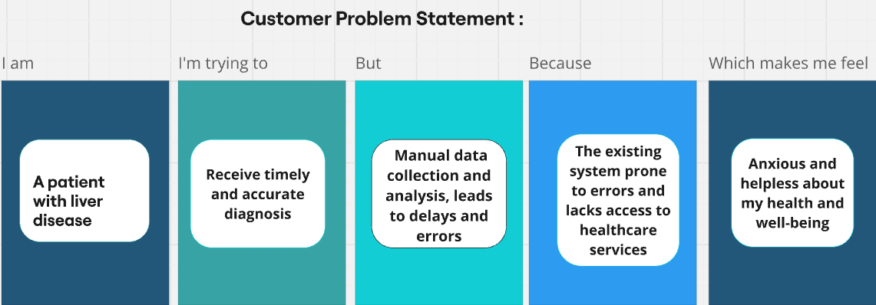

|  |  |  |  |  |  |
| --- | --- | --- | --- | --- | --- |
| **Problem**  **Statement (PS)** | **I am**  **(Customer)** | **I’m trying to** | **But** | **Because** | **Which makes me feel** |
| PS-1 | A healthcare provider | Identify liver patients in a timely manner | The current system relies on manual data collection and analysis, leading to delays and errors | The existing system is inadequate and inefficient | Concerned about the well-being of my patients |
| PS-2 | A patient with liver disease | Receive timely and accurate diagnosis and treatment | Manual data collection and analysis, leading to delays and errors | The existing system is prone to errors and lacks access to healthcare services | Anxious and helpless about my health and well-being |